County Contours 2024
Using Mississippi LiDAR sets and 1 to 4-foot resolution LiDAR DEMs (2015 – 2020) from MARIS , and other data and resources from USGS, NRCS, MDEQ, NOAA Coastal Services Center, Mississippi DOT, Mississippi State University, and Mississippi Coordinating Council for Remote Sensing and GIS , Waggoner Engineering developed one and two foot contours for 71 of Mississippi’s 82 counties.
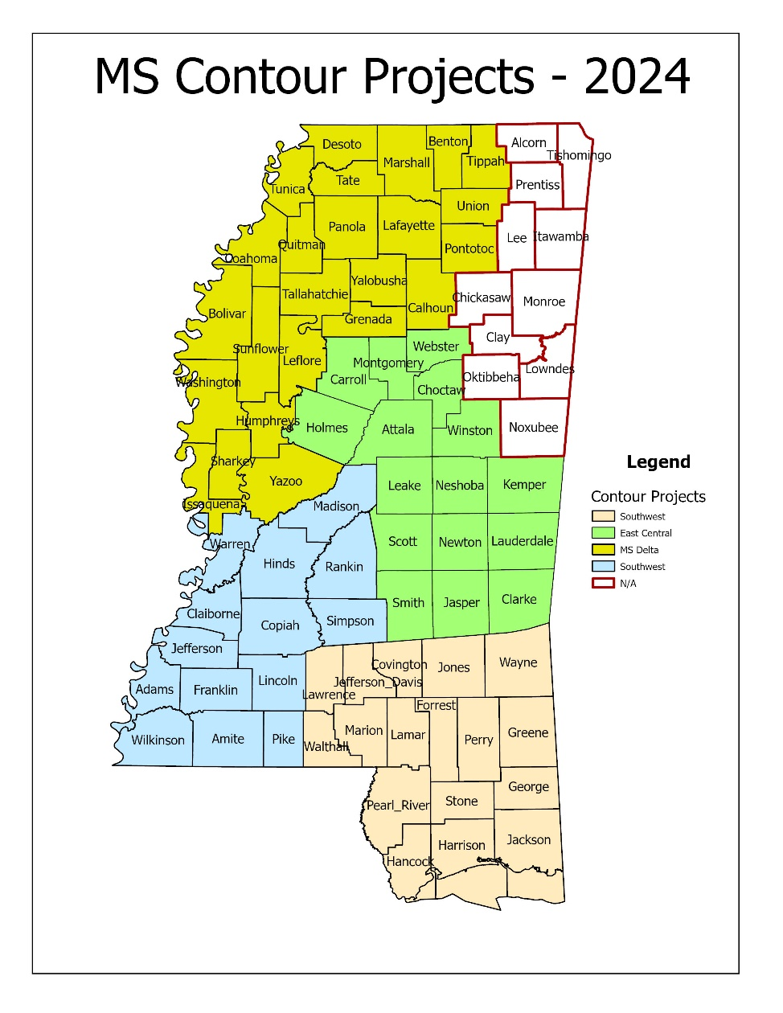
There were four project areas:
- East Central – Project Quality Report (Craig link .pdf here)
- MS Delta – Project Quality Report (Craig link .pdf here)
- Southwest MS – Project Quality Report (Craig link .pdf here)
- South MS – Project Quality Report (Craig link .pdf here)
This data is distributed in zipped geodatabase (.gdb) format with the following products:
- 1 foot contours by county (2d) - metadata (Craig link .pdf here)
- 2 foot contours by county (2d) - metadata (Craig link .pdf here)
- 1 foot contours by county (3d) - metadata (Craig link .pdf here)
- 2 foot contours by county (3d) - metadata (Craig link .pdf here)
Notes:
- There are also contours by Townships in the county geodatabases.
- The zip files are huge Over 15 GB each
- If you want the entire data set, we suggest sending an external USB Drive (at least 1TB) to --
MARIS 3825 Ridgewood Rd, Suite 717 Jackson, MS 39211

