9/9/2016: Coastal lidar 2015 Fix
Contractor resubmitted tiles to correct visible raised lines.
DEM 885 tiles, 2.38 GB LAS 295 tiles, 95 GB
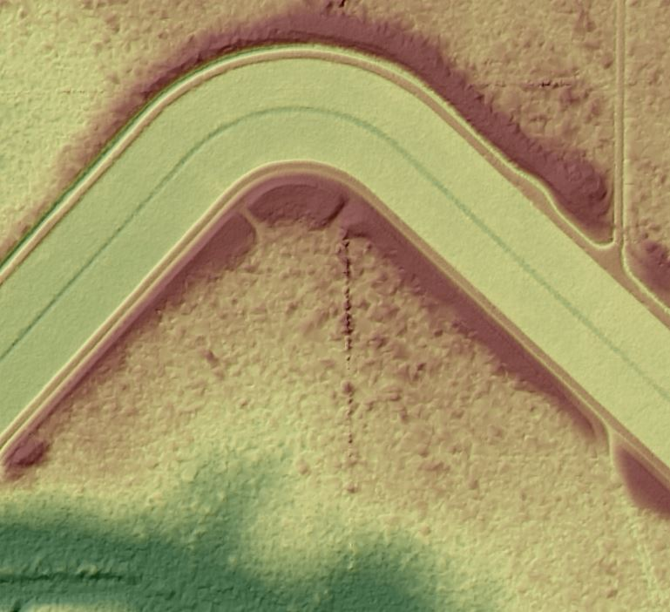 Original
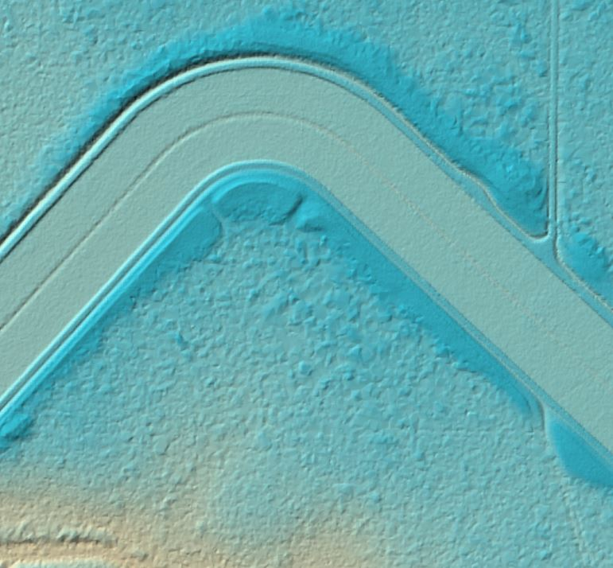 Fixed
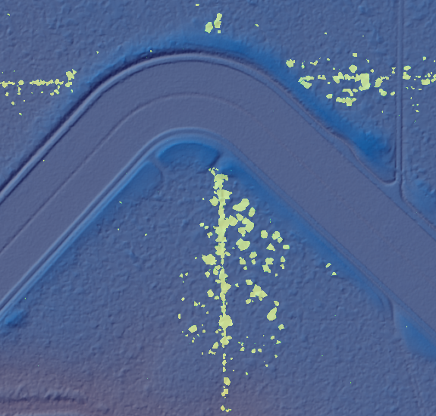 Change
I subtracted the 2 surfaces (raster math) and overlaid it on the Fixed tile with transparency. The yellow shows where the elevation was reduced. Blue = no change.

