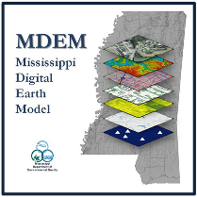 MS Cadastral Framework 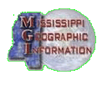
Data Disclaimer
August 2023 Release

In accordance with MDEQ guidance and requirements, MS Geographic Information,
Waggoner Engineering, Tri-State Consulting Services, Inc, and various county tax offices compiled and developed MDEM Cadastral Framework Data Layer for all Mississippi 82 counties including parcel polygons and center points of those polygons with all available data therein. This data contains over 40 attributes for each parcel.

The information provided in these County Parcel Data files do not, and are not intended to, constitute legal data; instead, all information, content, and materials available in these files are for general informational purposes only. This data may not constitute the most up-to-date legal or complete information. For the most up-to-date and complete county parcel data, the viewer should contact the specific county’s Tax Assessor/Collector office to acquire that data.

For more information, contact:

Stephen Champlin, RPG
Geospatial Resources Division/Flood Mapping Director
Office of Geology
Mississippi Department of Environmental Quality (MDEQ)
P.O. Box 2279, Jackson, MS 39225-2279
Office: 601-961-5506
Schamplin@mdeq.ms.gov

